

Name and Student ID:
​Lois Mathew (1179051)
​Nidhi Shailesh Patel (1179002)
​
​
​Instructor:
​Osama Amjad
​
​
​Project:
Internet Speed Monitor
​
​
​Course Number:
​ESOF-2571
​
​
​Course Name:
​Computer Hardware & Software Sys.
​Lakehead University
​Department of Software Engineering
​​

Raspberry Pi Internet Speed Monitor

Introduction
In today's connected world, having a stable and reliable internet connection is crucial for both personal and professional activities. However, monitoring the performance of your internet connection over time can be challenging without the right tools. This is where our Raspberry Pi Internet Speed Monitor project comes into play.

Project Overview
Our project aims to empower Raspberry Pi enthusiasts and internet users alike by providing a simple yet effective solution for monitoring internet speed and performance. By leveraging the capabilities of the Raspberry Pi and the Speedtest CLI tool from Ookla, users can easily track their download speed, upload speed, and ping latency over time.

Why Monitor Internet Speed?
Monitoring internet speed isn't just about satisfying curiosity. It serves several practical purposes:
- Performance Optimization: By tracking internet speed regularly, we can identify patterns and trends in their network performance. This information can help optimize network configurations and improve overall internet speed.
- Diagnosing Issues: Fluctuations in internet speed can indicate underlying issues such as network congestion or hardware problems. Monitoring internet speed allows us to diagnose and address these issues promptly.
- Peak Usage Analysis: Understanding peak usage times can help us schedule bandwidth-intensive tasks such as downloads or video streaming during off-peak hours, ensuring a smoother online experience.

Key Features
- Automated Monitoring: Our solution automates the process of conducting speed tests at regular intervals, eliminating the need for manual intervention.
- Data Visualization: We can visualize internet speed data using popular tools like Grafana for further analysis and comparison.
- Real-time Insights: With real-time monitoring capabilities, we can gain insights into how the internet connection performs under different conditions throughout the day.
Who Can Benefit?
Our Raspberry Pi Internet Speed Monitor is suitable for:
- Home Users: Individuals who want to ensure they're getting the internet speeds they're paying for and optimize their home network performance.
- Small Businesses: Small businesses or home offices that rely on a stable internet connection for their day-to-day operations can use this solution to monitor network performance and troubleshoot issues.
- Network Enthusiasts: Raspberry Pi enthusiasts and hobbyists interested in exploring network monitoring and data analytics can leverage this project to gain valuable insights into internet speed metrics.
By embarking on this project, users can gain a deeper understanding of their internet connection's performance and take proactive steps to optimize their online experience.

Setting up Raspberry pi:
Hardware Setup:
- Gathering Necessary Components:
  - Raspberry Pi board (Raspberry Pi 3 used in this project)
  - MicroSD card with the latest version of Raspberry Pi OS pre-installed
  - 5V micro USB power supply
  - HDMI cable for output
  - Keyboard and mouse for initial setup
  - Display monitor for output
  - Led
  - Capacitors
  - Jumper wires
- Preparing the MicroSD Card:
  - Downloaded the latest version of Raspberry Pi OS from the official website.
  - Used Raspberry Pi Imager tool to write the OS image to the microSD card.
  - Inserted the microSD card into the Raspberry Pi.
- Connecting Peripherals:
  - Connected the HDMI cable from the Raspberry Pi to the display monitor.
  - Connected the keyboard and mouse to the USB ports on the Raspberry Pi.
- Powering On:
  - Powered on the Raspberry Pi by plugging in the power supply to the micro USB port.
- Initial Setup:
  - Configured language, keyboard layout, and other preferences following on-screen prompts.
  - Enabled SSH and VNC for remote access as per project requirements.
- Updating Software:
  - Opened a terminal and ran commands sudo apt update and sudo apt upgrade to update software packages on the Raspberry Pi OS.
Software Setup:
- Acquiring Necessary Tools:
  - Ensured access to a computer capable of imaging the storage device.
  - Used a suitable storage device (microSD card) and connected it to the computer.
- Choosing Raspberry Pi Imager:
  - Opted to use Raspberry Pi Imager, compatible with macOS, Windows, and Linux.
- Installing Raspberry Pi Imager:
  - Downloaded the latest version of Raspberry Pi Imager from raspberrypi.com/software.
  - Installed it on the computer or used the package manager with sudo apt install rpi-imager.
- Launching Raspberry Pi Imager:
  - Clicked on the Raspberry Pi Imager icon or ran the command rpi-imager.
- Selecting Raspberry Pi Model and Operating System:
  - Clicked "Choose device" and selected the Raspberry Pi model.
  - Clicked "Choose OS" and selected the desired operating system.
- Connecting Storage Device:
  - Connected the microSD card to the computer using an SD card reader.
- Customizing Operating System:
  - Set up Raspberry Pi via OS customization settings, including username, password, WiFi credentials, device hostname, time zone, keyboard layout, and SSH.
- Applying OS Customization:
  - Saved customizations and applied them when writing the image to the storage device.
- Saving Customization and Writing Image:
  - Confirmed the write process and granted necessary permissions when prompted.
- Completing Write Process:
  - Waited for the write process to complete and verified its success.
  - Disconnected the storage device from the computer for Raspberry Pi booting.

Installing the Speedtest CLI:
Speedtest CLI is a command-line interface tool developed by Ookla, a company specializing in internet speed testing and analysis. It allows users to quickly and conveniently measure their internet connection speed directly from the terminal.
- Preparation: Before embarking on setting up the Raspberry Pi to monitor internet speed, we ensured that our system was up to date. To achieve this, we ran the following commands in the terminal:
sudo apt-get update sudo apt-get upgrade
- Installing Required Packages: We then proceeded to install the necessary packages to add the Speedtest CLI package repository. This was accomplished by executing the following command:
sudo apt install apt-transport-https gnupg1 dirmngr lsb-release
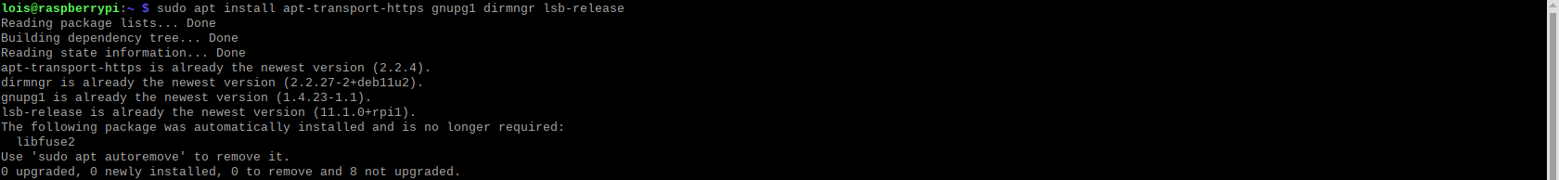

- Adding GPG Key: Next, we added the GPG key for Ookla's Speedtest repository to the keychain. This step was crucial for facilitating the download of the Speedtest CLI. We used the following command for this purpose:
curl -L https://packagecloud.io/ookla/speedtest-cli/gpgkey | gpg --dearmor | sudo tee /usr/share/keyrings/speedtestcli-archive-keyring.gpg
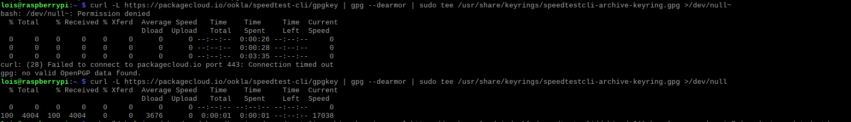
- Adding Repository: With the GPG key in place, we added the Ookla repository to our sources list. This was necessary to proceed with the installation of the Speedtest CLI. The command used for adding the repository was:
echo "deb [signed-by=/usr/share/keyrings/speedtestcli-archive-keyring.gpg] https://packagecloud.io/ookla/speedtest-cli/deb/ $(lsb_release -cs) main"
- Updating Package List: Following the addition of the new package repository, we updated our package list to ensure the latest packages were available. The command used for updating the package list was:
sudo apt update
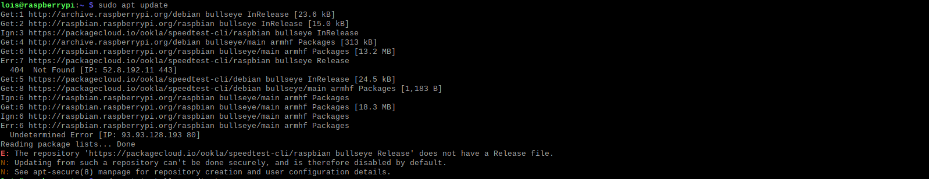
- Installing Speedtest CLI: Once the package list was updated, we proceeded with the installation of the official Speedtest CLI to our Raspberry Pi. This was accomplished by running the command:
sudo apt install speedtest
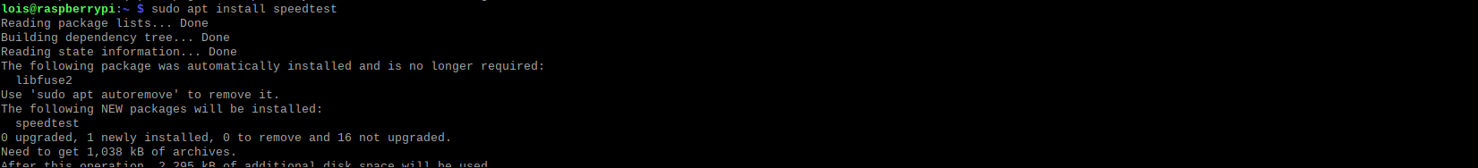
- Testing Installation: Finally, to confirm that the Speedtest software was successfully installed on our Raspberry Pi, we executed the following command:
speedtest
During the initial run, we were prompted to agree to terms and conditions, which we accepted by typing "YES" followed by the ENTER key.

Writing our Speed Test Python Script:

- Starting Script Creation: After successfully installing the Speedtest CLI on our Raspberry Pi, we proceeded to write a Python script that would continuously monitor our download and upload speeds. To initiate this process, we navigated to our home directory and created a new Python script file named speedtest.py by executing the following command:
cd ~ nano speedtest.py
Python Code:
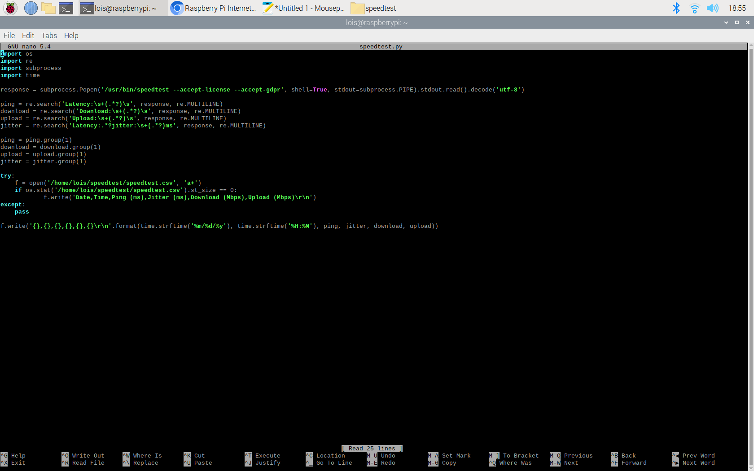

- Within the newly created file, we wrote the following lines of code to implement our speed test script. Each line of code serves a specific purpose.
import os
import re
import subprocess
import time
- These lines of code import necessary libraries that our script will rely on:
  - os: Used for interacting with the operating system, specifically to check if a file exists.
  - re: Enables regular expression handling, which we'll use to extract relevant data from the Speedtest CLI output.
  - subprocess: Essential for executing external commands, particularly to call the Speedtest CLI and capture its output.
  - time: Utilized for recording the date and time for each speed test, allowing us to track speeds over time.

response = subprocess.Popen('/usr/bin/speedtest --accept-license --accept-gdpr', shell=True, stdout=subprocess.PIPE)
- This line of code launches a call to the Speedtest CLI using the subprocess module. It initiates a subprocess and executes the speedtest command, accepting the license and GDPR agreements. The output of the command is captured and stored in the response variable.

ping = re.search('Latency:\s+(.*?)\s', response.stdout.read().decode('utf-8'), re.MULTILINE) download = re.search('Download:\s+(.*?)\s', response.stdout.read().decode('utf-8'), re.MULTILINE) upload = re.search('Upload:\s+(.*?)\s', response.stdout.read().decode('utf-8'), re.MULTILINE) jitter = re.search('Latency:.*?jitter:\s+(.*?)ms', response.stdout.read().decode('utf-8'), re.MULTILINE)
- These lines of code utilize regular expressions (regex) from the re library to search for specific patterns in the output obtained from the Speedtest CLI. They extract the values for ping, download speed, upload speed, and jitter, respectively, from the Speedtest CLI output.

ping = ping.group(1)
download = download.group(1)
upload = upload.group(1)
jitter = jitter.group(1)
- Here, we use the .group(1) function to extract the captured group from each regex search result. This step ensures that we obtain the numerical values of ping, download speed, upload speed, and jitter, which we'll use for further processing.

try: f = open('/home/lois/speedtest/speedtest.csv', 'a+') if os.stat('/home/lois/speedtest/speedtest.csv').st_size == 0:
f.write('Date,Time,Ping (ms),Jitter (ms),Download (Mbps),Upload (Mbps)\r\n') except: pass
- This block of code is enclosed in a try statement to handle potential errors gracefully without interrupting the script's operation. Here's what each line does:
  - Attempts to open the speedtest.csv file for appending data ('a+' mode).
  - Checks if the file is empty (zero bytes). If it's empty, writes column headers to the file.
  - The except block is provided as a catch-all to ensure the script doesn't terminate unexpectedly in case of errors.

f.write('{},{},{},{},{},{}\r\n'.format(time.strftime('%m/%d/%y'), time.strftime('%H:%M'), ping, jitter, download, upload))
- This line of code writes the data obtained from the speed test to the speedtest.csv file. It formats the data into a CSV (Comma-Separated Values) format, including the current date, time, ping, jitter, download speed, and upload speed. The time.strftime function is used to format the date and time.

- Saving the Script: After completing the script, we saved the file by pressing CTRL + X, then Y, and finally pressing ENTER.

- Creating Folder for CSV File: To store the CSV file generated by the script, we created a folder named speedtest in our home directory using the following command:
mkdir ~/speedtest

- Testing the Script: With the script created and the necessary folder in place, we proceeded to test the script's functionality by executing the following command:
python3 ~/speedtest.py

- Checking Results: After the script finished executing, we checked the results by opening the newly created speedtest.csv file using the following command:
nano ~/speedtest/speedtest.csv
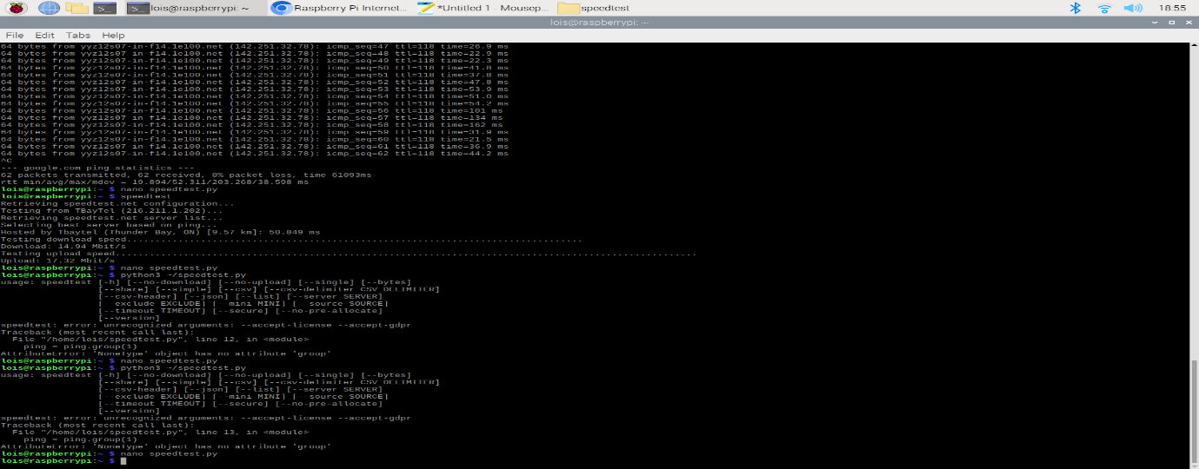

InfluxDB:
- InfluxDB proved to be a valuable tool for handling time series data efficiently.
- Functionality:
  - Data Storage: InfluxDB stores internet speed test results in a structured manner.
  - Database Organization: Data is organized within the "internetspeed" database, with measurements like "internet_speed."
  - Data Retrieval: Grafana accesses data from InfluxDB to visualize it in graphs and charts.
  - Integration with Grafana: InfluxDB serves as Grafana's data source, providing data for visualization.
- Real-Time Monitoring: With InfluxDB and Grafana, we can monitor internet speed data in real-time, enabling continuous tracking and analysis.
Overall, InfluxDB facilitates efficient storage and retrieval of internet speed data, enabling real-time monitoring and analysis through integration with Grafana.

Preparing the Raspberry Pi for InfluxDB:
- Updated Packages: Before proceeding with the installation of InfluxDB, we ensured that all installed packages were up to date. This step helped prevent potential conflicts and ensured a smoother installation process.
- Added the Repository Key: To install InfluxDB, we added its repository key to our Raspberry Pi. This key allowed the package manager to verify the authenticity of the packages being installed.
curl https://repos.influxdata.com/influxdata-archive.key | gpg --dearmor | sudo tee /usr/share/keyrings/influxdb-archive-keyring.gpg >/dev/null
- Added the Repository to Sources List: Following the addition of the key, we added the InfluxDB repository to the sources list. This step enabled the package manager to locate and fetch the necessary packages during installation.
echo "deb [signed-by=/usr/share/keyrings/influxdb-archive-keyring.gpg] https://repos.influxdata.com/debian stable main" | sudo tee /etc/apt/sources.list.d/influxdb.list
- Updated Package List: After adding the repository, we updated the package list to ensure that the package manager was aware of the newly added repository and its contents.
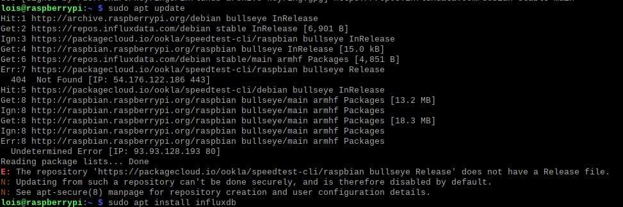
Installed InfluxDB to the Raspberry Pi:
- Installed InfluxDB: With the repository set up, we proceeded to install the InfluxDB software on our Raspberry Pi.
sudo apt install influxdb
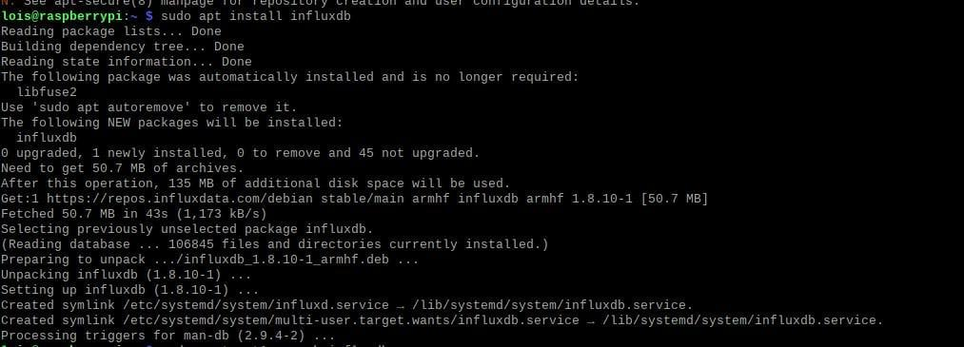
Started the InfluxDB Server:
- Enabled Autostart: To ensure that InfluxDB started automatically upon booting the Raspberry Pi, we enabled its service file using the systemctl service manager.
sudo systemctl unmask influxdb sudo systemctl enable influxdb
- Started the Server: Finally, we started the InfluxDB server using systemctl. This command initiated the service, making it available for use.
sudo systemctl start influxdb

Used InfluxDB V1 on the Raspberry Pi:
- Explored InfluxDB: After installation, we were able to interact with InfluxDB using its command-line interface. This interface allowed us to create databases, insert data points, and perform queries.

Following these steps, we successfully installed InfluxDB on our Raspberry Pi, enabling us to store and manage time series data efficiently.

Testing out InfluxDB V1:
- Started Interacting with the Database: After installing InfluxDB V1, we began communicating with the database. To initiate this interaction, we launched Influx's command-line tool.
- Created a Database: Since InfluxDB doesn't come with any databases by default, our initial task was to create one. We created a database named "newdb" to store our data.
- Selected the Database: To modify our newly created database, we instructed the CLI to use it.
- Understanding InfluxDB's Datastore: Before adding data, we gained a basic understanding of InfluxDB's datastore, which organizes data into time series. Each data point consists of a time, measurement name, and field.
- Added Data Points: We proceeded to add our first data point to the database, representing the temperature in the living room as 20 degrees Celsius.
- Performed Queries: With sample data in place, we demonstrated how to retrieve data using the SELECT statement. We retrieved all data from the "temperature" measurement.
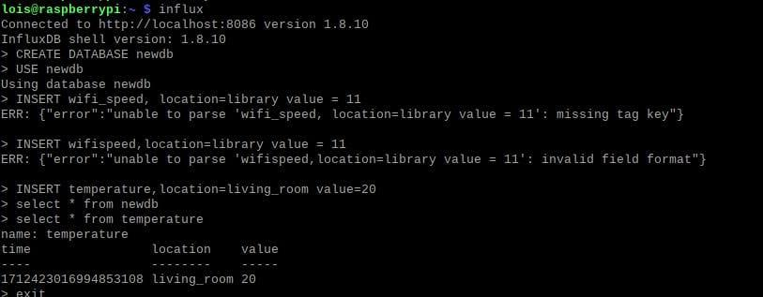

Modifying InfluxDB Configuration for Authentication:
- Opened the InfluxDB CLI tool by running the following command:
influx
- Created Admin: Within the InfluxDB CLI tool, created a new admin user with full access to the database by running the following command:
CREATE USER admin WITH PASSWORD '<password>' WITH ALL PRIVILEGES
This command will create a new user named "admin" with the specified password and grant it all privileges, effectively setting it up as an admin account with full access to the database.

- Modified Configuration File: After completing data testing, we proceeded to modify the InfluxDB configuration file to enable authentication.
sudo nano /etc/influxdb/influxdb.conf
- Added Authentication Options: Within the configuration file, we located the [HTTP] section and added options to enable authentication.
[HTTP] auth-enabled = true pprof-enabled = true pprof-auth-enabled = true ping-auth-enabled = true
- Saved Configuration Changes: After adding the authentication options, we saved the file by pressing CTRL + X, followed by confirming the changes.
- Restarted the Service: To apply the configuration changes, we restarted the InfluxDB service.
sudo systemctl restart influxdb
- Entered Username and Password: With authentication enabled, we provided the username and password when using the InfluxDB CLI tool.
influx -username admin -password <password>
By completing these steps, we successfully tested InfluxDB on our Raspberry Pi, gaining insights into its data handling capabilities and enabling authentication for improved security.

Setting up InfluxDB for our Internet Speed Monitor:
- Initiated InfluxDB Command-line Tool: We began by starting the InfluxDB command-line tool to create a database where our internet speed monitor data will be stored. If authentication is enabled, we provided the username and password.
influx -username admin -password <password>
- Created Database: We proceeded to create a database named "internetst" within InfluxDB using the CREATE DATABASE command.
CREATE DATABASE internetst
- Created User: Next, we created a user named "speedmonitor" to interact with the database. We assigned a password to the user for security.
CREATE USER "speedmonitor" WITH PASSWORD '123'
- Granted Privileges: To allow the user "speedmonitor" to access and modify the "internetspeed" database, we granted all privileges to the user.
GRANT ALL ON "internetst" to "speedmonitor"
- Exited Command-line Tool: After completing the database setup, we exited the InfluxDB command-line tool.
quit
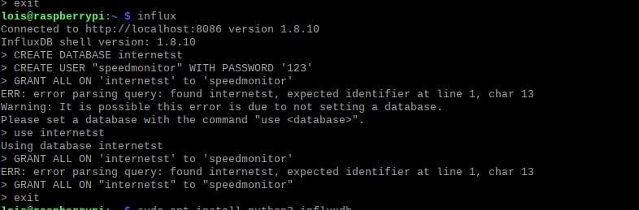
- Installed Python Library: We installed the Python library required to interact with our InfluxDB database.
sudo apt install python3-influxdb
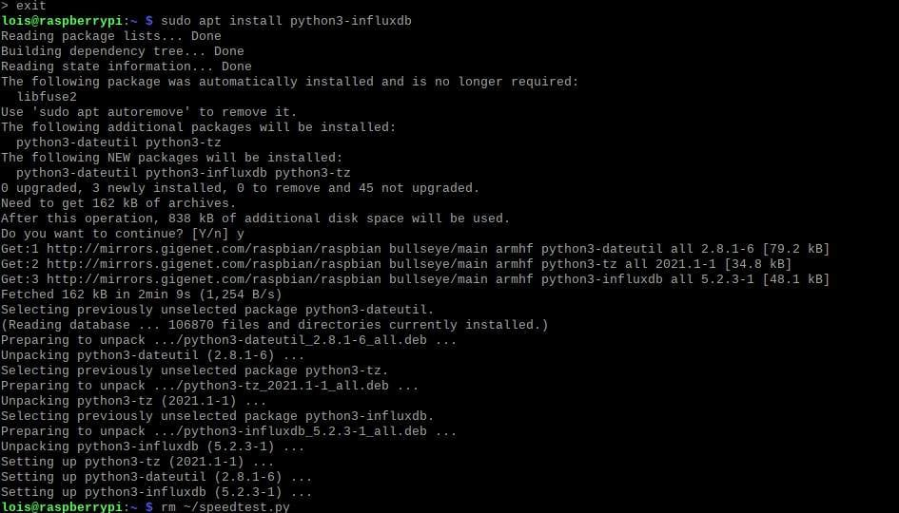
Saving our Speed Monitor Data to our InfluxDB:
- Created Python Script: To add data to our InfluxDB database, we created a new Python script named "speedtest.py".
rm ~/speedtest.py nano ~/speedtest.py
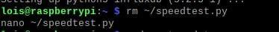
- Imported Required Libraries: Within the Python script, we imported necessary libraries, including re for regular expressions, subprocess for executing shell commands, and InfluxDBClient for interacting with InfluxDB.
import re import subprocess from influxdb import InfluxDBClient
- Processed Speed Test Data: We executed the Speedtest CLI tool and extracted relevant data such as ping, download speed, upload speed, and jitter using regular expressions.
response = subprocess.Popen('/usr/bin/speedtest --accept-license --accept-gdpr', shell=True, stdout=subprocess.PIPE).stdout.read().decode('utf-8')
ping = re.search('Latency:\s+(.*?)\s', response, re.MULTILINE)
download = re.search('Download:\s+(.*?)\s', response, re.MULTILINE)
upload = re.search('Upload:\s+(.*?)\s', response, re.MULTILINE)
jitter = re.search('Latency:.*?jitter:\s+(.*?)ms', response, re.MULTILINE)
ping = ping.group(1)
download = download.group(1)
upload = upload.group(1)
jitter = jitter.group(1)
- Formatted Data: We formatted the extracted data into a dictionary compatible with InfluxDB's data format, ensuring conversion of values to floats for accurate representation.
speed_data = [ { "measurement": "internet_speed", "tags": { "host": "RaspberryPiMyLifeUp" }, "fields": { "download": float(download), "upload": float(upload), "ping": float(ping), "jitter": float(jitter) } } ]
- Established Connection to InfluxDB: We instantiated the InfluxDBClient and provided connection details such as host, port, username, password, and database name.
client = InfluxDBClient('localhost', 8086, 'speedmonitor', 'pimylifeup', 'internetspeed')
- Wrote Data to Database: Finally, we wrote the speed test data to the InfluxDB database using the write_points method.
client.write_points(speed_data)
- Saved Script and Exited Editor: After completing the script, we saved the changes and exited the text editor.
Save the file by pressing CTRL + X, followed by Y, then ENTER.
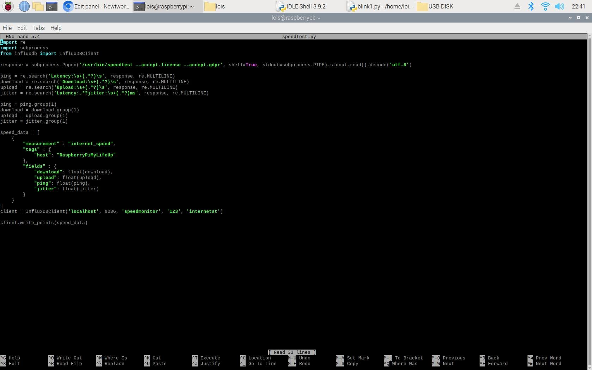

Grafana:
Grafana, an open-source metric analytics and visualization suite, is designed to facilitate the visualization of time-based data. It efficiently handles tasks such as rendering graphs by offloading them to the client side, which contributes to its speedy performance. This feature makes Grafana particularly well-suited for platforms with limited computational resources, like the Raspberry Pi. By leveraging Grafana, the Raspberry Pi can effectively manage data visualization tasks without being overwhelmed by processing demands. Consequently, Grafana emerges as a versatile and efficient solution for a wide range of monitoring and visualization requirements, including our internet speed monitoring project.

Setting up Grafana on the Raspberry Pi:
- Ensured Package Updates: Before installing Grafana on the Raspberry Pi, we ensured that all currently installed packages were up to date. This was achieved by running two commands to update the package list and upgrade installed packages.
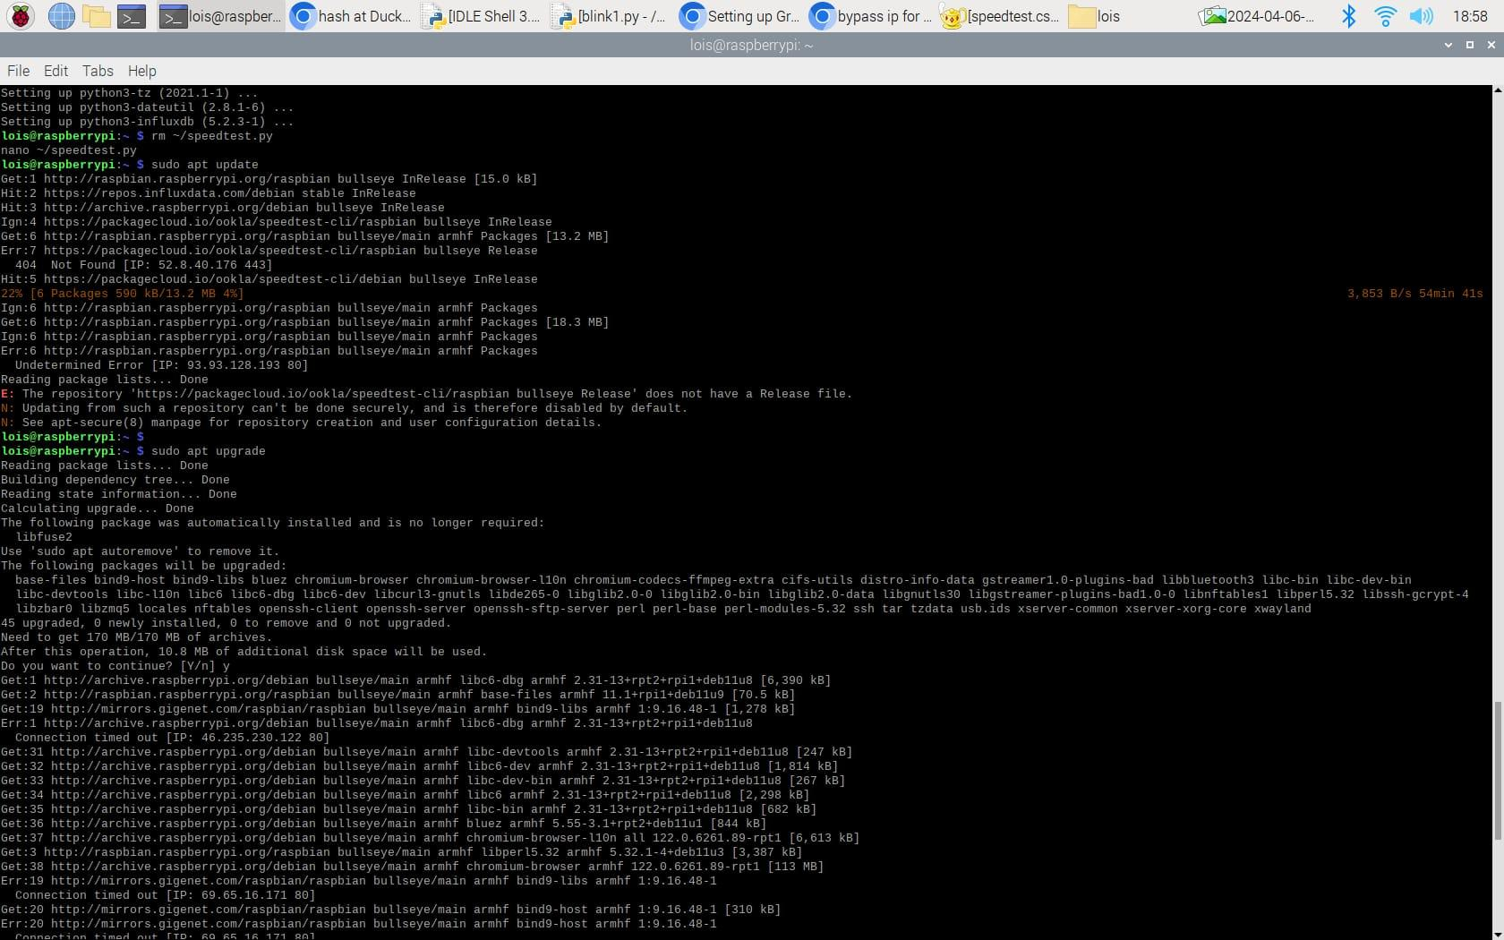
- Added Grafana Repository: To install Grafana, we added the Grafana package repository to the Raspberry Pi's sources list. First, we added the Grafana APT key to the keychain to verify package authenticity.
curl https://apt.grafana.com/gpg.key | gpg --dearmor | sudo tee /usr/share/keyrings/grafana-archive-keyrings.gpg >/dev/null
- Added Repository to Package Sources: With the APT key added, we proceeded to add the Grafana repository to the Pi's list of package sources.
echo "deb [signed-by=/usr/share/keyrings/grafana-archive-keyrings.gpg] https://apt.grafana.com stable main" | sudo tee /etc/apt/sources.list.d/grafana.list
- Updated Package List: Following the addition of the repository, we updated the package list to include Grafana packages.
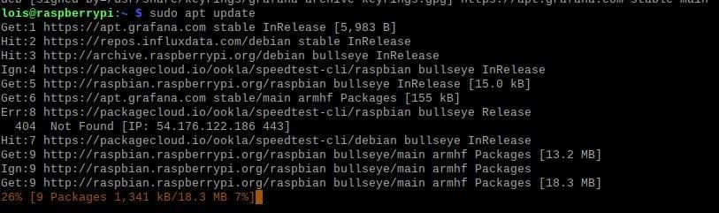
- Installed Grafana: After updating the package list, we installed Grafana on the Raspberry Pi using the apt package manager.
sudo apt install grafana
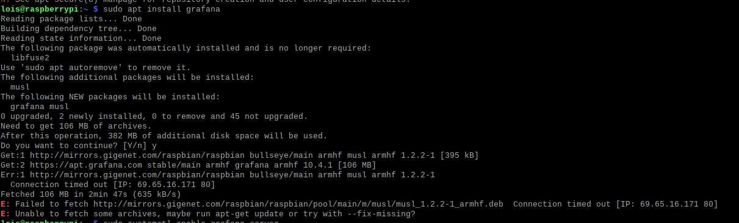
- Enabled Autostart: To ensure Grafana starts automatically at boot, we enabled the Grafana systemd service.
sudo systemctl enable grafana-server
- Started Grafana Server: Finally, we started the Grafana server software using systemd.
sudo systemctl start grafana-server

Connecting to your Raspberry Pi Grafana Installation:
- Retrieved IP Address: After Grafana installation, we retrieved the local IP address of the Raspberry Pi to access Grafana's web interface.
hostname -I
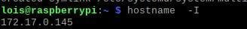
- Accessed Web Interface: Using the IP address obtained, we accessed Grafana's web interface via a web browser. Grafana typically sits on port 3000 of the Raspberry Pi's IP address.
http://172.17.0.145:3000
- Logged In: Upon accessing the Grafana web interface, we logged in using the default admin user credentials. The default username is "admin", and the password is also "admin".
- Changed Default Password: Upon initial login, we were prompted to change the default password for security reasons. We skipped this one.
- Greeted with Dashboard: After successfully logging in, we were greeted with the Grafana dashboard, which indicated that the Grafana setup on the Raspberry Pi was complete.

Viewing our Internet Speed Data in Grafana:
- After setting up Grafana, we opened its web interface by accessing our Raspberry Pi's or server's IP address, followed by port :3000.
- Within the Grafana web interface, we added a new data source by hovering over the cog in the sidebar and selecting the "Data Sources" menu option.
- In the subsequent menu, we clicked the "Add data source" button to proceed.
- On the "Add data source" page, we found InfluxDB, hovered over it, and clicked the "Select" button.
- Next, we entered the details of our InfluxDB installation, including the URL (e.g., http://localhost:8086), database name ("internetspeed"), username ("speedmonitor"), and password ("pimylifeup"). Then, we clicked the "Save & Test" button.
- We created a dashboard to display the data by hovering over the addition icon (+) in the sidebar and selecting the "Dashboard" option.
- Within the "New Panel," we clicked the "Add Query" button.
- We set up the graph to read from our database by selecting the measurement name ("internet_speed").
- After setting the measurement, we selected the field data we wanted to observe, such as "download," "upload," or "ping."
- To treat each result as a distinct individual result, we clicked the addition (+) button in the select row and selected "distinct" from the "Aggregations" menu.
- We gave each field a better name for clarity, such as "Download Speed," by setting the alias.
- After adding each field to the graph, we clicked the spanner and cog symbol in the sidebar.
- In the "Title" option, we typed in "Network Speed" to be displayed above the graph and saved the dashboard.
- We named our dashboard "Network Speed Monitor" and saved it.
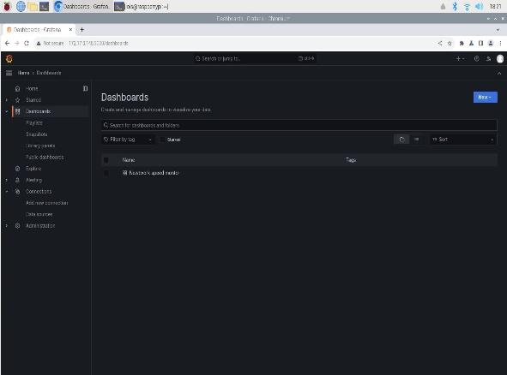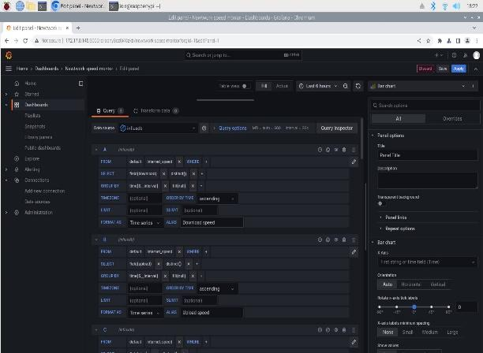

Different forms of output:
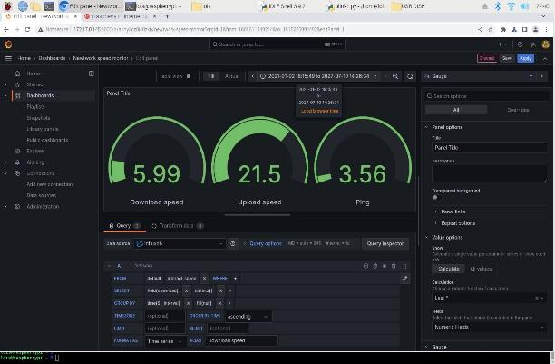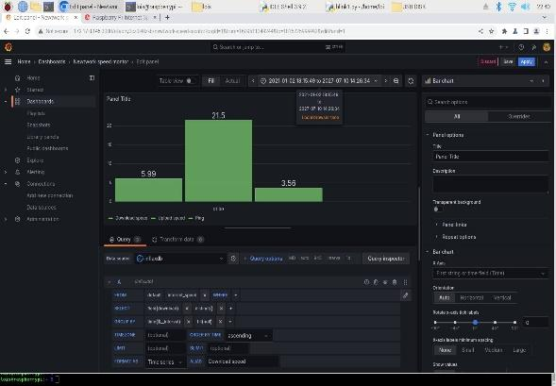

Automating our Speed Monitor script with Grafana:

- Automation Setup: We employed crontab, a time-based job scheduler in Unix-like operating systems, to automate the execution of our speed monitoring script. Crontab allows users to schedule recurring tasks at specified intervals without manual intervention.
- Configuring Crontab: To configure crontab, we accessed the system's cron table by running the command crontab -e on our Raspberry Pi. This command opens the crontab file in a text editor, enabling us to add or modify cronjobs.
- Adding Cronjob: Within the crontab file, we appended a new cronjob entry specifying the frequency and command to execute our Python script. In our case, we used the cron syntax */30 * * * * to run the script every 1 minute, followed by the command python3 /home/pi/speedtest.py to execute the script.
- Saving Changes: After adding the cronjob, we saved the changes to the crontab file by pressing CTRL + X, then confirming the save by pressing Y, and finally pressing ENTER to exit the text editor. Upon saving, the crontab file was automatically updated, and the new cronjob took effect immediately.
- Automatic Execution: With the cronjob configured, the system automatically executed our speed monitoring script every 1 minute as specified. This automation ensured continuous monitoring of internet speed data without the need for manual intervention, providing users with regular updates on their network performance.
By utilizing crontab to automate the execution of our speed monitoring script, we streamlined the monitoring process, enabling hassle-free data collection and analysis. This automation ensures that users always have up-to-date information on their internet speed, contributing to proactive network management and optimization.

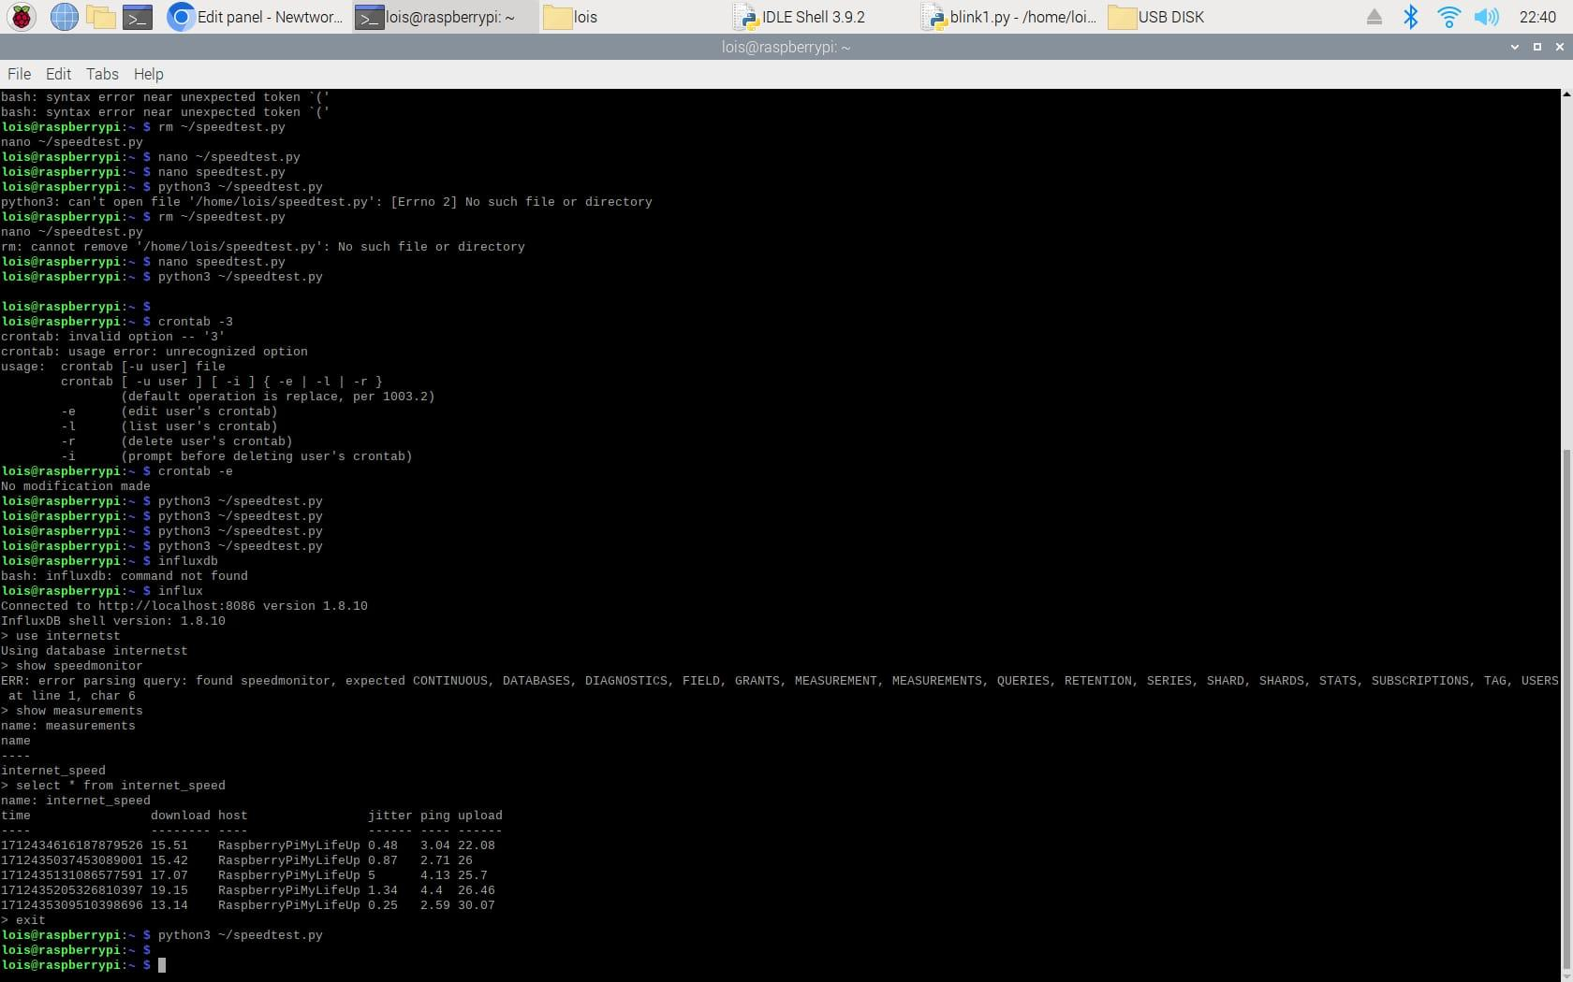
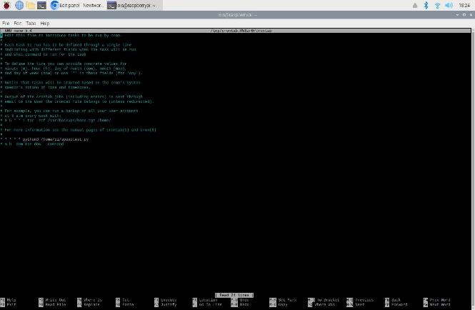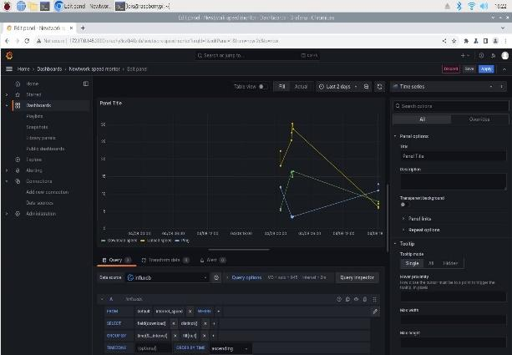

LED Connection:
Connected an LED to the Raspberry Pi entails establishing a circuit where the LED's anode connects to a GPIO 4 pin and the cathode connects to a current-limiting resistor, which, in turn, connects to the Pi's ground pin. The GPIO pin controls the flow of current to the LED, allowing it to be turned on or off programmatically.

Circuit Diagram:
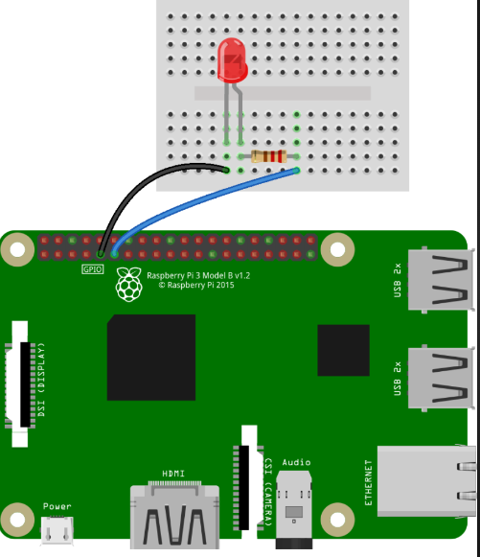

Our Visual:
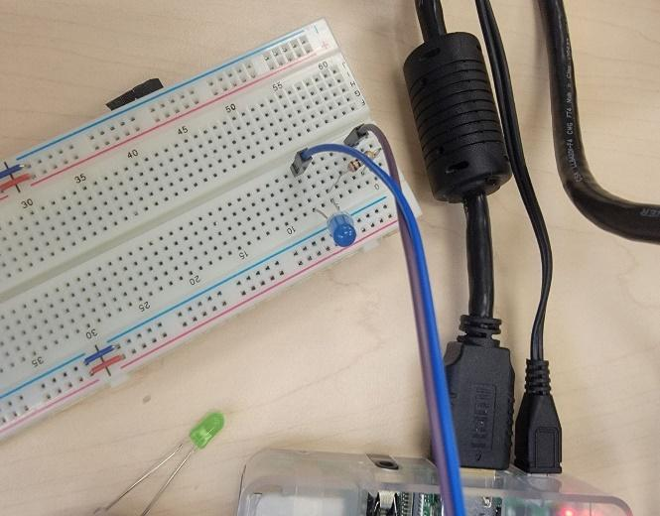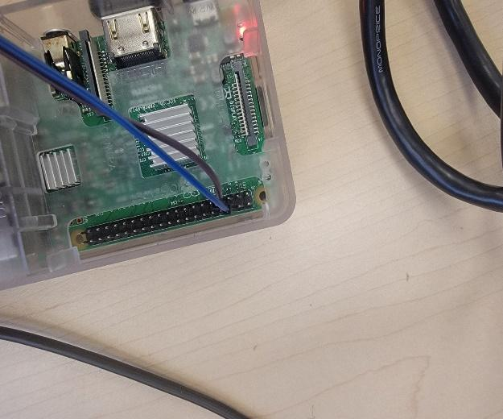

The LED's behavior is controlled based on the internet speed data obtained from the Speedtest CLI. Here's how the LED would work with the Python code:

- Data Retrieval: The Python script fetches internet speed data using the Speedtest CLI, which includes metrics such as ping, download speed, and upload speed.
- Data Processing: After obtaining the speed data, the script processes it to extract relevant information, such as the download speed.
- LED Control: Depending on the download speed value, the Python code determines the behaviour of the LED. For instance:
  - As the download speed increases, the LED starts blinking at a faster rate, visually indicating higher network activity.
  - The intensity or frequency of blinking could be proportional to the download speed, providing a more intuitive representation of network speed.
- Feedback Loop: The LED's behaviour serves as visual feedback, allowing us to quickly gauge the current state of internet speed without needing to check the terminal output or graphical interface.

By integrating the LED with the Python code, we can receive real-time visual cues about their network performance, enhancing the overall user experience and making it easier to monitor internet speed at a glance.

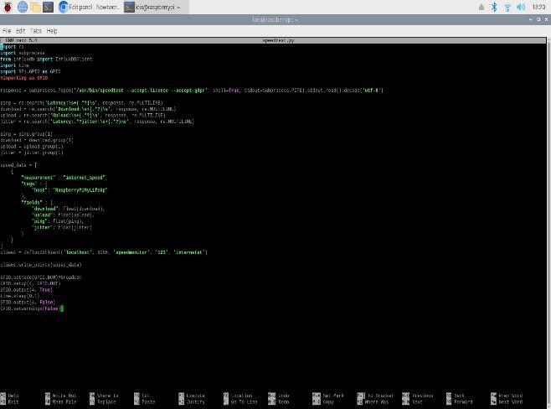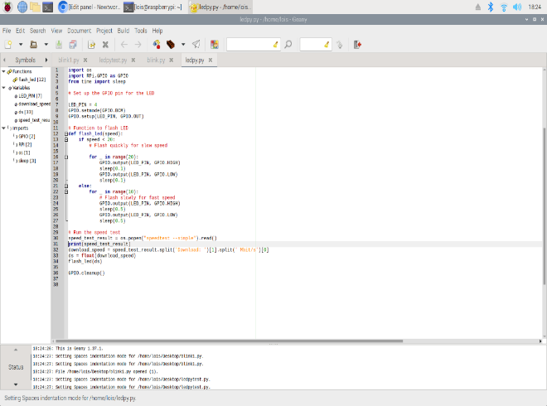

- Originally, we planned to connect two more LEDs for upload and ping indicators, but the obstacle lies in the limitation of available jumper wires. Due to the insufficient number of jumper wires on hand, connecting additional LEDs becomes challenging.

Future Works:

- GUI Development: Design and implement a graphical user interface (GUI) for the internet speed monitoring application. This GUI can provide users with a more user-friendly and intuitive way to interact with the monitoring system, displaying real-time speed metrics and historical data in a visually appealing manner.

- Alerting Mechanism: Implement an alerting mechanism to notify users of significant changes or anomalies in internet speed metrics. This can involve setting threshold values for ping, download, or upload speeds, and triggering alerts (e.g., email notifications, SMS alerts) when these thresholds are exceeded or deviate from expected values. Alerts can help users proactively address network issues and ensure optimal performance.

Appendix

[1] Github link to codes:
Github_link

